Core JAVA – Introduction

JDK, JRE, JVM

Installing the JDK, Setting up the JAVA_HOME and adding Jdk to the path in environment variable

Executing a Simple JAVA Program (HelloWorld)

Data Types, Statements, Operators,

Class & Objects

OOPs Concepts (Abstraction, Inheritance, Encapsulation & Polymorphism)

JAVA – It’s a General purpose, Object Oriented, Multi Threaded, Highly secured, platform independent programming Lang.

It’s developed by “James Ghosling” & Team in Sun Micro System

Now currently oracle merged this company with it.

Downloading the JDK

Latest version of Java is Java17.

But we are learning JAVA8 (java 1.8)

<https://www.oracle.com/java/technologies/downloads/#java8-windows> (64bit version) -- [jdk-8u321-windows-x64.exe](https://www.oracle.com/java/technologies/downloads/#license-lightbox)

Open command prompt

Type java -version

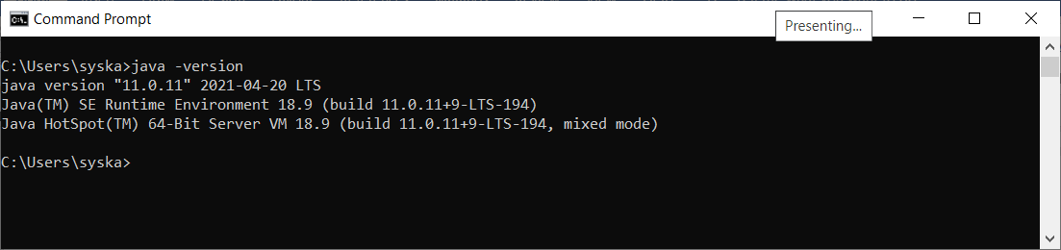

1. Environment Variable (key, value pair)

JAVA_HOME = C:\Program Files\Java\jdk1.8.0_281

Path = %JAVA_HOME%\bin

Echo %JAVA_HOME%

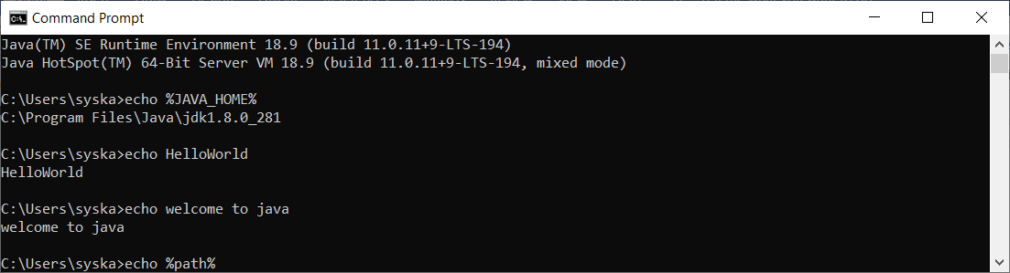

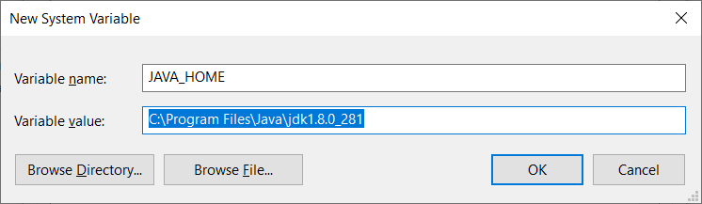

Update the following entry to the path environment variable

%JAVA_HOME%\bin

Eclipse EE IDE - <https://www.eclipse.org/downloads/download.php?file=/technology/epp/downloads/release/2021-12/R/eclipse-jee-2021-12-R-win32-x86_64.zip>

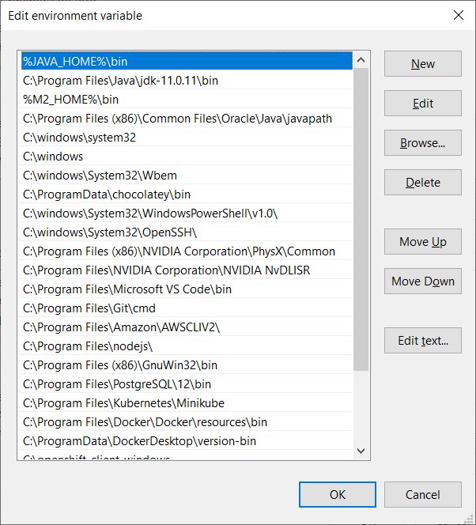

Close the existing command prompt and open a new command prompt

Java -version

Java 1.8.x

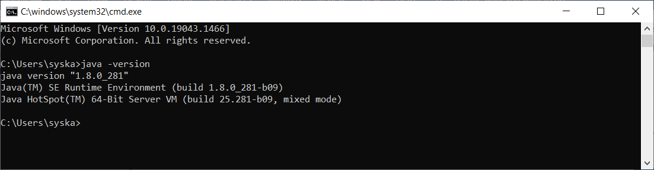

First Proj – in Eclipse

Public class MyClass {

Public static void main(String args[]){

System.out.println(“Hello World”);

}

}

JAVA Programming Lang

Learning French (Reference Lang - English)

1) Learn Alphabets, vowels, consonants

2) Learn words (words will have pre-defined meaning)

3) Learn to create sentences (grammer)

4) Learn to write para, read and write

5) Learn to write poem, watch movies….

Learn Programming Lang (Java – C)

1. Learn what are all the alphabets, numbers, symbols can be used
2. Learn keyword
3. Learn to create variables, statements, writing simple programs (syntax)
4. Learn resolving complex problems using the lang
5. Learn to create projects & Enterprise level applications

In Java

1. No explicit pointer manipulation
2. No direct Memory mgmt. (like malloc, alloc in c)
3. No multiple inheritance
4. No “goto” statement

Imp Java Features

1. Platform Independent
2. Highly Secured
3. Object Oriented Programming Lang
4. Portable
5. Multi-Threaded
6. General purpose (We can create a DBMS, Android, Big-data, Pega, Banking Applications)

Different Editions of JAVA

1. JAVE SE – Java Standard Edition (Core JAVA)
2. JAVE EE – Java Enterprise Edition (Core JAVA + Addl Technologies = Adv JAVA)
3. JAVA ME – Java Micro/Mobile Edition

JAVA = JDK + JRE

JDK – Java Development Kit – Super Set of JRE (JRE+ More Tools) = JDK [Modifying the source code and re-compiling is possible with the help of JDK only.

JRE – Java Runtime Environment - Used to run the Java project/Application

Javac – Java Compiler

JVM – Java Virtual Machine (Virtual Computer created using softwares only)

Java is platform independent bcos of JVM.

But, both JDK, JRE & JVM are all platform dependent.

Java is a case sensitive language.

Here we can use A-Z, a-z, 0-9, +,-,*,/,%, ++, --, ., ->, ::, ;, , =, +=,-=,*=,/=, ==, !=, |, ||, &, &&, ~, @, (), [], {},

Operators

1. Arithmetic Operator (+,-,*,/,%, =,)
2. Relational Operators (<,>, <=, >=, ==, !=)
3. Bitwise Operator (&, |, !, ^, ~, <<, >>)
4. Logical Operators ( &&, ||, !)
5. Increment & decrement operator (++, --) / unary operator (Single Operand)
6. Ternary operator (expr)?true section:false section; (one line if else)

Data Types (8 primitive data types)

1. Primitive Data types /Built-in data types
2. Derived data types [ arrays, class, enum…]

Boolean – 1 bit

Byte – 8 bits – 1 Byte

Short – 16 bits – 2 byte

Char – 16 bits – 2 Bytes

Int – 32 bits – 4 Bytes

Float –

Long – 64 bits – 8 bytes (Only whole numbers [integers])

Double – 64 bits – 8 bytes ( Decimal numbers allowed)

Signed & unsigned are behavior modifiers

Statements / Control Statements

1. Conditional Control Statements (if, nested if, if else, else if ladder, switch)
2. Repetitive or Looping Control Statements (for, while, do while)
3. Normal Statements

Y=mx+c (Mathematical formula) == Java Expression y=(m*x)+c;

Order of Execution – Operator precedence

Class & Object

Class – It’s a blue print to create object

Object – Instance of a class

I need to draw a circle.

1. Take a ring/ take a bangle/take a coin/take a compass/ Pro-circle [stencil]
2. Use pen, pencil, sketch pen, marker, chalk piece,

Coin [5 rupee coin]

1. I can create n number of circles using the same 5 re coin.
2. I can create different circles by using different pens, pencils, markers, chalk piece…
3. Each object will have some individual property
4. Objects will have both property as well as behavior

Property & behavior

Car – property

1. Engine
2. No of tires
3. No of Seats
4. speed = 0;
5. yearOfMfg ;
6. modelName;
7. noOfGears;

behaviors / methods (functions written inside a class)

changeGear()

accelerate()

applyBrake()

changeDirection()

access Modifiers (who & how can access)

1. private 2) default/package 3) protected 4) public

non-access modifiers (change behavior )

1. static 2) final 3) abstract 4) transient

Arrays – Fixed in size, store similar data in a continuous memory